Customer payment side -> a different account to be used:

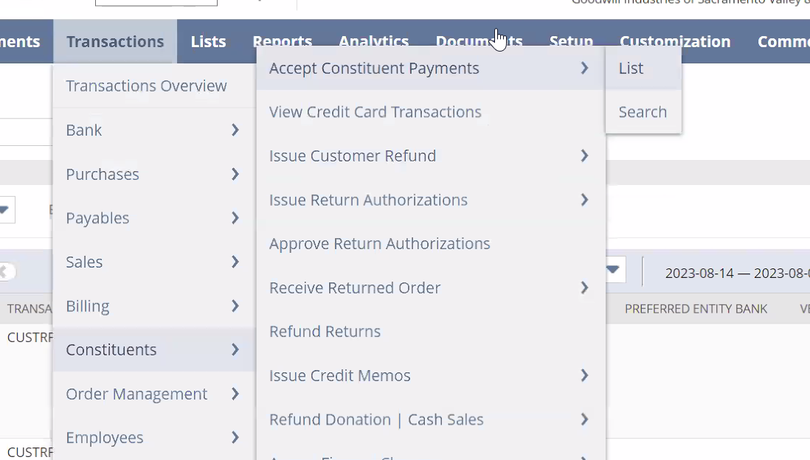
They wanted on a different cash account, and currently NSPOS always use the same:
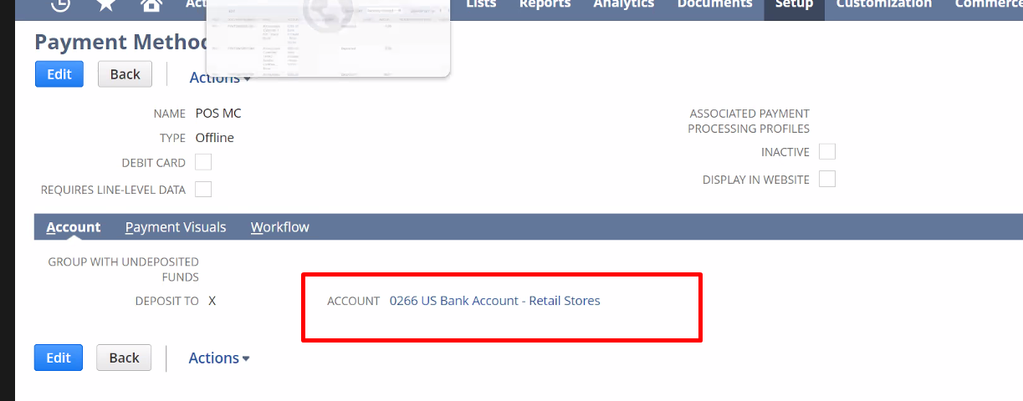

Regardles of the deposit method, it assigns an account by default:
